Prelude

Recognition of August Birthdays and Anniversaries

*Trinity Chimes

*Invocation and Lord’s Prayer
Unison: Our Father, who art in heaven, hallowed be Thy name. Thy Kingdom come. Thy will be done on earth as it is in heaven. Give us this day our daily bread. And forgive us our trespasses, as we forgive those who trespass against us. And lead us not into temptation, but deliver us from evil. For thine is the kingdom, and the power, and the glory. Forever. Amen.

*Hymn # 127……………………...............................................”To God Be the Glory”

*Responsive Reading Psalm 17
Leader: Hear, O Lord, and answer my prayer. May my vindication come from you.
People: May your eyes see what is right.

Leader: Though you probe my heart and test me, you will find nothing.
People: I have resolved that my mouth will not sin.

Leader: I have kept myself from the ways of evil.
People: My steps have held to your paths; my feet have not slipped.

Leader: You who save by your right hand, keep me as the apple of your eye;
People: Hide me in the shadow of your wings from the wicked who assail me.

Leader: O Lord, by your hand save me from those of this world whose reward is in this life. Their satisfaction is in wealth they have stored.
People: Hear, O Lord. Answer my prayer that in righteousness, I will be satisfied with seeing your likeness.

Gloria Patri (front of hymnal – second tune)

Scripture Lesson………………………………………………..……...Matthew 14:22-33 (16)

Special Music

Morning Prayer

Congregational Response (Back of hymnal)………………….……...”Threefold Amen”

Children’s Moment

Offering for Ministry and Missions
Offertory Interlude
*Doxology (front of hymnal) and Prayer

Hymn # 289……………………………………………………………..…..…...”Blessed Assurance”

Scripture Lesson………………………………………………………..…...Genesis 32:22-31 (30)

Sermon…………………………………..………………..…..”Relying On God’s Salvation Plan”

*Hymn # 144…………………………………………………………..…….………….”Only Trust Him”

*Announcements (move to front during last verse of hymn)

*Benediction

*Postlude

*Stand as you are able.

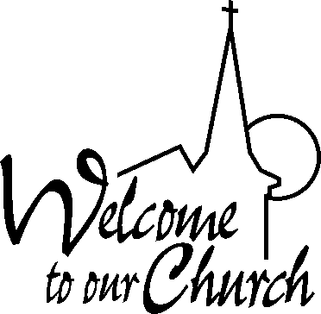
Welcome to all who worship with us this morning. We are glad you have joined us and want you to feel warmly welcomed to this community of faith and hope you will experience the Holy Spirit moving in this place. If you are a visitor, please fill out a visitor’s card and place it in the offering plate and sign the visitor’s book in the vestibule.

Wednesday 10:30 a.m. Prayers and Praise in the Sanctuary.
12:30-3:00 p.m. WCC Adult Art Classes in the Fellowship Hall – something for everyone – join us.
7:15-8:30 p.m. Beth Moore’s “Loving Well” Bible Study in the home of DeWitt and Anita Holland.

Thursday 7:15-8:30 p.m. Beth Moore’s “Loving Well” Bible Study in the home of DeWitt and Anita Holland. This is the same study being done on Wednesday evenings for the convenience of those who could not attend on Wednesday.

Next Sunday 9:30 a.m. Coffee Time in the Fellowship Hall.
Sun., Sept. 10 12:15 p.m. Rally Day with a covered dish luncheon. Put it on your calendar and plan to join us for some good food and fellowship – more details to follow in the September Newsletter.

GREETERS Today – DeWitt and Anita Holland
Next Sunday – R. A. and Nancy Howell

LAY READER Today – Bentley Richardson
Next Sunday –

COUNTERS Today – Jamie MacKenzie and Bentley Richardson
Next Sunday – Beverly Parsons and Carolyn Scott

SUMMER ADULT CLASS SUNDAY SCHOOL TEACHERS – class meets in the Sanctuary through the end of August.

August 13 Pastor Sam
August 20 Jim O’Briant
August 27 Kathy Queen

Notes: There is a Nursery Sign-up Sheet on the cabinet in the vestibule along with Sign-up Sheets for Flowers and Lay Readers. We encourage you to review these lists and sign up if you are able to help in any way.

The Board of Christian Education would like to have two separate classes for the children beginning in September – a Pre-School Class and a School Age Class. We already have two Sundays covered in each class but will need additional teachers for two Sundays. Please contact Mary Catherine or another member of that committee if you would be willing to teach one of the classes a Sunday each month.

The Year-to-date giving statements are in the mailboxes – please take them with you when you leave.

Windsor Congregational
Christian Church

August 6, 2017
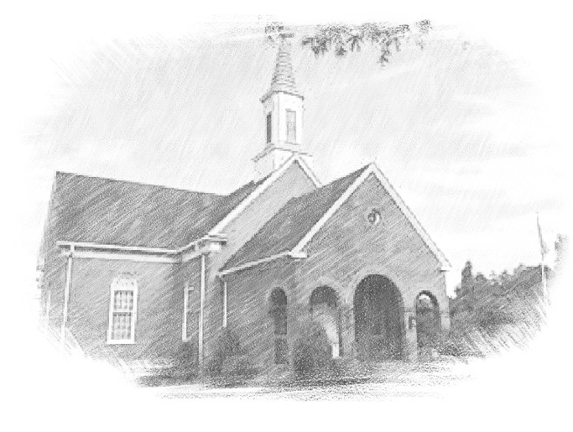
4 North Court St - PO Box 407
Windsor, VA 23487

Rev. R Samuel Askew, Pastor
Sid Neighbours, Music Director
Nancy Bland, Admin. Secretary/Treasurer
Mike and Courtney Roggmann, Audio Technicians
Church: 757-242-4794 Pastor: 757-642-7945
staff@windsorchristian.org samaskew@msn.com
Website: windsorchristian.org

